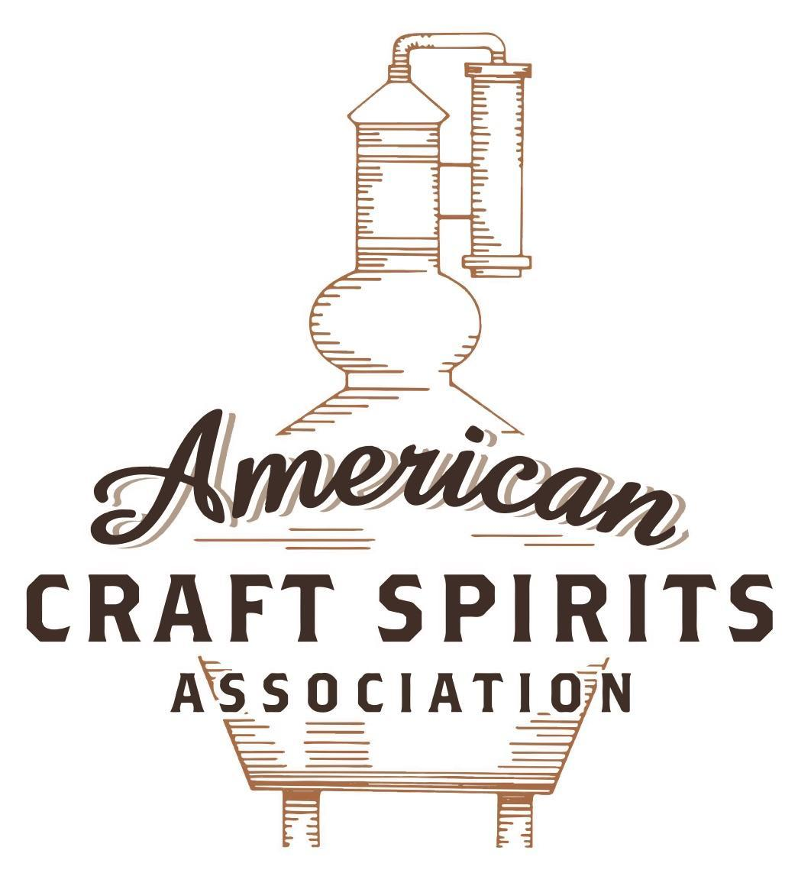
Spirits DtC Shipping Guide

This guide summarizes the direct-to-consumer shipping rules for distilleries in all 50 states and D.C. and also addresses the measures state governments have taken to ease delivery and shipping restrictions during the COVID-19 pandemic.

DtC Quick Guide Comparison

Out-of-State Distilleries  Can Ship Into State? |  |  |  | In-State Distilleries  Can Ship Within State?
State | Yes | No |  | State | Yes | No
AL |  | X |  | AL |  | X
AK | X |  |  | AK | X
AZ | X |  |  | AZ | X
AR |  | X |  | AR |  | X
CA |  | X* |  | CA |  | X*
CO |  | X |  | CO |  | X
CT |  | X* |  | CT |  | X
DE |  | X |  | DE |  | X
DC | X |  |  | DC | X
FL |  | X |  | FL |  | X
GA |  | X |  | GA |  | X
HI |  | X* |  | HI |  | ?*
ID |  | X |  | ID |  | X
IL |  | X* |  | IL |  | X*
IN |  | X |  | IN |  | X
IA |  | X* |  | IA |  | X*
KS |  | X |  | KS |  | X
KY | X |  |  | KY | X
LA |  | X |  | LA |  | X
ME |  | X* |  | ME |  | X*
MD |  | X |  | MD |  | X
MA |  | X |  | MA |  | X
MI |  | X |  | MI |  | X
MN |  | X |  | MN |  | X
MS |  | X |  | MS |  | X
MO |  | X |  | MO |  | X
MT |  | X |  | MT |  | X
NE | X |  |  | NE | X
NV |  | X* |  | NV |  | X
NH | X |  |  | NH |  | X*
NJ |  | X* |  | NJ |  | X*
NM |  | X |  | NM |  | X
NY |  | X* |  | NY |  | X*
NC |  | X |  | NC |  | X
ND | X |  |  | ND | X
OH |  | X |  | OH |  | X
OK |  | X |  | OK |  | X
OR |  | X |  | OR | X
PA |  | X* |  | PA |  | X
RI |  | X* |  | RI |  | X
SC |  | X |  | SC |  | X
SD |  | X |  | SD |  | X
TN |  | X |  | TN |  | X
TX |  | X |  | TX |  | X
UT |  | X |  | UT |  | X
VT |  | X |  | VT |  | X
VA |  | X |  | VA |  | X
WA |  | X* |  | WA | X
WV |  | X* |  | WV |  | X*

WI |  | X |  | WI |  | X
WY |  | X |  | WY |  | X

Notes:
*CA: If passed and signed into law, Senate Bill 620 would allow licensed distilled spirits producers in states other than California and licensed distilled spirits manufacturers or craft distillers in California who obtain distilled spirits direct shipper permits to ship directly to consumers in California
*CT: Consumers with appropriate permit may receive alcohol shipments
*HI: Consumers with appropriate permit may receive alcohol shipments; If passed and signed into law, Senate Bill 65 would allow licensed distilled spirits manufacturers in Hawaii and in states other than Hawaii who obtain direct shipper permits to ship directly to consumers in Hawaii
*IL: If passed and signed into law, Senate Bill 0532 would allow licensed distilled spirits producers in Illinois and in states other than Illinois who obtain distillery shippers’ licenses to ship directly to consumers in Illinois
*IA: If passed and signed into law, House File 639 would allow native distilled spirits manufacturers in Iowa and in states other than Iowa who obtain direct shipper permits to ship directly to consumers in Iowa and to consumers in states other than Iowa
*ME: If passed and signed into law, Legislative Document 1358 would allow distilleries outside of Maine with current manufacturer licenses and distilleries licensed in Maine who obtain spirits direct shipper licenses to ship directly to consumers in Maine
*NJ: (1) If passed and signed into law, Assembly Bill 3167 would allow a craft distillery licensees to ship no more than 9 liters of distilled spirits to a consumer in New Jersey; (2) If passed and signed into law, Senate Bill 3020 would allow craft distillery licensees in New Jersey or in states other than New Jersey to ship no more than 20 liters of distilled spirits to a consumer in New Jersey via common carrier
*NV: Licensed individuals can import one gallon per month of spirits for personal use and the out-of-state supplier must pay excise tax
*NH: If passed and signed into law, Senate Bill 125 would allow licensed liquor manufacturers who obtain direct to consumer shipping permits from the commission to ship directly to consumers in New Hampshire
*NY: Consumer may import up to 90L of liquor per year for personal use without a license; If passed and signed into law, Assembly Bill 3275 would allow licensed liquor manufacturers in states other than New York and licensed distillers and farm distillers in New York to ship no more than thirty-six cases (no more than nine liters per case) of liquor to consumers in New York
*PA: Consumer may place a special liquor order and distiller must ship to a PLCB-operated store
*RI: Distiller can only ship to customer if order was personally placed by customer at distiller's premises
*WA: If passed and signed into law, House Bill 1432 would allow licensed spirits manufacturers in states other than Washington to ship spirits to consumers in Washington
*WV: Distilleries, mini-distilleries, or micro-distilleries licensed in West Virginia or a state other than West Virginia who obtain private direct shipper licenses to ship to a consumer in West Virginia, however the shipments must be made to a retail liquor outlet

NEVADA
Shipment Outbound – Yes, craft distilleries may export to another state not more than a combined total of 40,000 cases of spirits at all the craft distilleries the person operates, and estate distilleries are limited to 400,000 cases (NRS 597.235(2)(c); NRS 597.237(2)(d)).
Shipment Inbound – No, however, licensed individuals can import one gallon per month of spirits for personal use and the out-of-state supplier must pay excise tax (NRS 369.490; NRS 369.462).
Shipment Intra-state – No, craft and estate distilleries may only sell at their premises their product at retail for consumption on or off the premises (NRS 597.235(e); NRS 597.237(f)).
COVID-19 Measures – While delivery privileges have concerned restaurants, breweries and wineries, no explicit relief for distilleries has been addressed.
Citation (shipment)
Nevada Revised Statutes
NRS 369.490 Unlawful possession, sale or transportation of liquor; exceptions.
1. Except as otherwise provided in subsection 2 and NRS 369.176, a person shall not directly or indirectly, himself or herself or by his or her clerk, agent or employee, offer, keep or possess for sale, furnish or sell, or solicit the purchase or sale of any liquor in this State, or transport or import or cause to be transported or imported any liquor in or into this State for delivery, storage, use or sale therein, unless the person:
(a) Has complied fully with the provisions of this chapter; and
(b) Holds an appropriate, valid license, permit or certificate issued by the Department.
2. Except as otherwise provided in subsection 3, the provisions of this chapter do not apply to a person:
(a) Entering this State with a quantity of alcoholic beverage for household or personal use which is exempt from federal import duty;
(b) Who imports 1 gallon or less of alcoholic beverage per month from another state for his or her own household or personal use;
(c) Who:
(1) Is a resident of this State;
(2) Is 21 years of age or older; an
(3) Imports 12 cases or less of wine per year for his or her own household or personal use; or
(d) Who is lawfully in possession of wine produced on the premises of an instructional wine-making facility for his or her own household or personal use and who is acting in a manner authorized by NRS 597.245.
3. The provisions of subsection 2 do not apply to a supplier, wholesaler or retailer while he or she is acting in his or her professional capacity.
4. A person who accepts liquor shipped into this State pursuant to paragraph (b) or (c) of subsection 2 must be 21 years of age or older.
Link: https://www.leg.state.nv.us/nrs/nrs-369.html#NRS369Sec490

NRS 369.462 Payment of tax by supplier.
A supplier who ships liquor into this state pursuant to paragraph (b) or (c) of subsection 2 of NRS 369.490 must pay the excise tax levied pursuant to NRS 369.330.
Link: https://www.leg.state.nv.us/nrs/nrs-369.html#NRS369Sec462
NRS 597.235 Operation of craft distillery.
2. A person who operates a craft distillery pursuant to this section may:
(c) In any calendar year, manufacture for exportation to another state, not more than a combined total of 40,000 cases of spirits at all the craft distilleries the person operates.
(e) On the premises of the craft distillery, sell the spirits manufactured at the craft distillery at retail for consumption on or off the premises. Any such spirits sold at retail for off-premises consumption must not exceed, per person, per month, 1 case of spirits and not exceed, per person, per year, 6 cases of spirits. Spirits purchased on the premises of a craft distillery must not be resold by the purchaser or any retail liquor store.
Link: https://www.leg.state.nv.us/nrs/nrs-597.html#NRS597Sec235

NRS 597.237 Operation of estate distillery. [Effective through September 30, 2025.]
2. A person who operates an estate distillery pursuant to this section may:
(d) In any calendar year, manufacture for exportation to another state, not more than a combined total of 400,000 cases of spirits at all the estate distilleries the person operates.
(f) On the premises of the estate distillery, sell the spirits manufactured at the estate distillery at retail for consumption on or off the premises. Any such spirits sold at retail for off-premises consumption must not exceed, per person, per month, 1 case of spirits and not exceed, per person, per year, 6 cases of spirits. The total amount of such spirits sold at retail for off-premises consumption must not exceed 7,500 cases per year. Spirits purchased on the premises of an estate distillery must not be resold by the purchaser or any retail liquor store. A person who operates an estate distillery shall prominently display on the premises a notice that the resale of spirits purchased on the premises is prohibited.
Link: https://www.leg.state.nv.us/nrs/nrs-597.html#NRS597Sec237

The American Craft Spirits Association (ACSA) is working diligently to give our members and industry partners relevant, current updates on statutes and regulations impacting production, sale and distribution of spirits. With the declaration of the novel coronavirus (COVID-19) in early 2020, many states have issued temporary policy changes or longer-term modernization of alcohol beverage laws. State statutes, regulations created by the state alcohol regulatory authority, as well as any other relevant guidance provided by such authorities (such as advisories, opinions, bulletins, etc.) were reviewed in creation of this document. No city or county ordinances were reviewed. Distillers should be aware that even in states where direct shipping is permissible, always remember to avoid shipping to dry counties. Please consult with your state guild or alcohol beverage authority for the most up-to-date information. This content is intended for educational and informational purposes only. ACSA's pro bono law firm of Malkin Law P.A. provided the core content found in this comprehensive overview of the spirits distribution after COVID-19. It was completed in August 2021 and will be updated regularly. If you have updates you would like to provide, please send to legislation@americancraftspirits.org or directly to the law firm at: ryan@malkin.law / malkin.law. Thank you.

